**DESIGN AND IMPLEMENTATION OF E-LEARNING SYSTEM**

**(A CASE STUDY OF DEPARTMENT OF COMPUTER SCIENCE, NUHU BAMALLI POLYTECHNIC, ZARIA)**

**BY**

**LAWAN MUKHTAR MUHAMMAD**

**BU/21C/IT/5894**

**IN PARTIAL FULFILMENT OF THE REQUIREMENT FOR THE AWARD OF BACHELOR OF SCIENCE IN INFORMATION SYSTEMS MANAGEMENT, FACULTY OF COMPUTING AND APPLIED SCIENCE, NUHU BAMALLI POLYTECHNIC, ZARIA.**

**DECEMBER, 2023**

# DECLARATION

I hereby declared that this research project has been written by me under the supervision of Dr. Usman Bello Abubakar. The work has been presented in any previous research for the award of B.Sc degree to the best of my knowledge. The work is entirely mine and I accept the sole responsibility for any errors that might be found in the work, while the reference to publish material have been duly acknowledge.

__________________________ _____________________

Lawan Mukhtar Muhammad Date

BU/21C/IT/5894

**APPROVED BY**

………………..

**H.O.D**

Dept. of Computer Science

# CERTIFICATION

This project entitled “Design and Implementation of E-learning system (a case study of department of computer science, Nuhu Bamalli polytechnic, Zaria)” meets the requirements governing the award of Bachelor of Science in Information Systems Management in Baze University, Abuja.

# APPROVAL PAGE

# This is to certify that the research work title Design and Implementation of E-learning system (a case study of department of computer science, Nuhu bamalli polytechnic, Zaria) by Lawan Mukhtar Muhammed with BU/21C/IT/5894 has been approved by the Department of Computer Science, Faculty of Computing and Applied Science, Baze University, Abuja, Nigeria.

By

Dr. Usman Bello Abubakar

Supervisor Date

Assoc Prof. Chandrashekhar Uppin

Head of Department Date

Prof. Peter Ogedebe

Dean, Faculty of Computing and Applied Science Date

Prof. Choji Davou Nyap

External Examiner Date

# DEDICATION

I would like to dedicate this research project titled “Design and Implementation of E-Learning System (A Case Study of Department of Computer Science, Nuhu Bamalli Polytechnic, Zaria)” to my beloved parents. Their unwavering support, guidance, and inspiration have been instrumental in the completion of this work. Their belief in my abilities and encouragement throughout this journey have been invaluable. I am grateful for the love, understanding, and sacrifices made by them. This dedication is a token of my appreciation for their constant support and belief in my aspirations.

# ACKNOWLEDGEMENT

I would like to express my sincere gratitude and appreciation to all those who have contributed to the completion of this research project. Their support, guidance, and assistance have been significant in shaping this work.

I extend my heartfelt thanks to my supervisor, Dr. Usman Bello Abubakar for his invaluable guidance, expertise, and encouragement throughout this research endeavor. His insightful feedback and constructive criticism have been instrumental in refining my ideas and improving the quality of this work.

I am deeply grateful to the Faculty Members, Advisors, Instructors, for their valuable contributions, insightful discussions, and technical assistance.

Furthermore, I am indebted to my family and friends for their unwavering support, understanding, and encouragement throughout this journey. Their love and motivation have been my driving force.

Lastly, I would like to express my gratitude to all the participants who willingly participated in this study, as their contributions have enriched the findings and conclusions of this work.

Thank you all for your support and guidance, which have been instrumental in the successful completion of this research project.

# ABSTRACT

The e-learning system is a digital platform designed to facilitate online education, providing a flexible and accessible learning environment for students and instructors. It leverages technology to deliver educational content, interactive learning experiences, and collaborative tools through the internet. The system encompasses various features and functionalities, including course management, student enrollment, instructor support, resource sharing, assessments, and communication tools. In the e-learning system, students can access a wide range of courses and educational materials from anywhere, at any time, using their personal computers or mobile devices. They can engage in self-paced learning, participate in interactive multimedia lessons, and collaborate with peers through discussion forums and virtual classrooms. The system provides a student-centered approach, allowing learners to progress at their own pace and tailor their learning experience to their individual needs. The e-learning system provides numerous benefits, including flexibility in terms of time and location, personalized learning experiences, access to a wide range of courses and resources, and the ability to accommodate a large number of learners simultaneously. It serves as an alternative or complement to traditional classroom-based education, offering convenience, scalability, and cost-effectiveness. As technology continues to advance, the e-learning system evolves to incorporate new features such as artificial intelligence, virtual reality, and adaptive learning algorithms. These advancements enhance the interactivity, personalization, and effectiveness of the e-learning experience, further revolutionizing the way education is delivered and consumed.

# TABLE OF CONTENTS

TITLE PAGE i

DECLARATION ii

CERTIFICATION iii

APPROVAL PAGE iv

DEDICATION v

ACKNOWLEDGEMENT vi

TABLE OF CONTENTS vii

LIST OF TABLES xi

LIST OF FIGURES xii

ABSTRACT xiv

CHAPTER ONE 1

INTRODUCTION 1

1.1 Overview 1

1.2 Background and Motivation 1

1.3 Statement of the Problem 3

1.4 Aim and Objectives 4

1.5 Significance of the Project 4

1.6 Project Risks Assessment 5

1.7 Scope/Project Organization 6

CHAPTER TWO 7

LITERATURE REVIEW 7

2.1 Introduction 7

2.2 Historical Overview 7

2.3 Related Work 8

2.3.1 Benefits of E-learning Systems 13

2.3.2 Challenges of E-Learning Systems 13

2.4 Comparative Analysis 14

2.5 Summary 18

CHAPTER THREE 19

REQUIREMENTS, ANALYSIS, AND DESIGN 19

3.1 Overview 19

3.2 Methodology 19

3.3 Proposed Model 20

3.4 Tools and Techniques 20

3.5 Ethical Considerations 21

3.6 Requirement Analysis 21

3.6.1 Software Requirements 21

3.6.2 Hardware Requirements 22

3.7 Requirements Specifications 22

3.7.1 Functional Requirements 22

3.7.2 Non-functional Requirements 23

3.8 System Design 24

3.8.1 Application Architecture 24

3.8.3 Use case description 25

3.8.4 Entity Relationship Diagram 26

3.8.5 Activity Diagram 27

3.9 Summary 31

CHAPTER FOUR 32

IMPLEMENTATION AND TESTING 32

4.1 Overview 32

4.2 Main Features 32

4.3 Implementation Problems 33

4.4 Overcoming Implementation Problems 34

4.5 Testing 35

4.5.1 Test Plans 35

4.5.1.1 Unit Testing 35

4.5.1.2 Integration Testing 35

4.5.1.3 System Testing 36

4.5.1.4 Test Results 37

4.6 Use Guide 37

4.7 User Interface Design 38

4.8 Summary 46

CHAPTER FIVE 47

DISCUSSION, CONCLUSION, AND RECOMMENDATIONS 47

5.1 Overview 47

5.2 Objective Assessment 47

5.3 Limitations and Challenges 48

5.4 Future Enhancements 49

5.5 Recommendations 50

5.6 Summary 50

REFERENCES 52

APPENDIX-SOURCE CODE 54

# LIST OF TABLES

Table 1.15

Table 2.114

Table 3.122

Table 3.223

Table 4.136

Table 4.237

Table 4.337

# LIST OF FIGURES

Figure 3.119

Figure 3.220

Figure 3.324

Figure 3.424

Figure 3.525

Figure 3.626

Figure 3.727

Figure 3.828

Figure 3.929

Figure 3.1030

Figure 4.138

Figure 4.239

Figure 4.339

Figure 4.440

Figure 4.540

Figure 4.641

Figure 4.741

Figure 4.842

Figure 4.942

Figure 4.1043

Figure 4.1143

Figure 4.1244

Figure 4.1344

Figure 4.1445

Figure 4.1545

Figure 4.1646

# CHAPTER ONE

# INTRODUCTION

# 1.1 Overview

In recent years, the advancement of technology has revolutionized various aspects of our lives, including education. Traditional methods of teaching and learning are being supplemented, and in some cases replaced, by digital platforms that offer flexibility and convenience. E-learning systems have emerged as an effective solution to deliver educational content to a wide audience, breaking the barriers of time and location. This chapter provides an overview of the design and implementation of an e-learning system, specifically focusing on the Department of Computer Science at Nuhu Bamalli Polytechnic in Zaria, Kaduna.

# 1.2 Background and Motivation

The concept of e-learning has evolved significantly over the past few decades, enabled by advancements in technology and internet connectivity. As early as the 1960s, Stanford University experimented with using computers for instructional purposes, developing the Computer Curriculum Corporation (CCC) system for elementary schools (Harasim, 2000). In the 1970s and 1980s, e-learning took the form of providing course content via teleconferencing and educational television (Bates, 2005).

The Internet boom of the 1990s paved the way for the emergence of the first learning management systems (LMS) and massive open online courses (MOOCs) (Harasim, 2000). One of the first notable LMS was WebCT, introduced in 1995, which allowed instructors to create online course content and monitor student progress (Paulsen, 2002). As high-speed broadband became widely accessible in the 2000s, e-learning evolved into a robust online education solution integrating multimedia, simulations, and virtual environments (Bates, 2005).

According to a study by Allen and Seaman (2017), higher education institutions in the United States witnessed steady year-over-year growth in online enrollment between 2012 to 2016. In Nigeria, the National Open University of Nigeria (NOUN) was established in 1983 as the first exclusively online university, aimed at increasing access to higher education (Jegede, 2002). The COVID-19 pandemic further accelerated the adoption of e-learning, with universities forced to shift to remote learning during campus closures (Odunayo et al., 2020).

This rapid evolution of e-learning highlights its potential to transform and improve higher education. The aim of implementing e-learning at Nuhu Bamalli Polytechnic is to leverage these technological advancements to enhance the student learning experience. The motivation lies in addressing the limitations of traditional classroom teaching and providing flexible, interactive education leveraging online platforms.

The motivation behind designing and implementing an e-learning system at Nuhu Bamalli Polytechnic stems from recognizing the limitations of traditional classroom teaching methods and the need to leverage technology to enhance the learning experience. Some key motivations include:

1. Providing flexibility and convenience: E-learning allows students to access educational resources and participate in learning activities at their own pace and schedule, without the constraints of attending physical lectures (Davies et al., 2017). This provides flexibility for students to balance education with other responsibilities.
2. Enabling remote learning continuity: As evidenced during the COVID-19 pandemic, e-learning platforms allow education to continue uninterrupted in times of disruption when physical presence on campus is not possible (Odunayo et al., 2020).
3. Improving student engagement: E-learning systems facilitate new interactive methods of teaching such as online quizzes, forums, and gamification that can increase student engagement and motivation (Lao & Gonzales, 2005).
4. Bridging theory and practice: E-learning provides opportunities to seamlessly integrate practical demonstrations, simulations, and multimedia content to support theoretical learning (Ghavifekr & Athirah, 2015).
5. Expanding access: An e-learning system increases access to education by removing geographical barriers and enabling students from different locations to participate (Olaniran, 2006).

In summary, the core motivations are to enhance the quality of teaching and learning, improve student outcomes, provide flexible access, and ultimately enable Nuhu Bamalli Polytechnic to leverage technology to deliver an engaging and effective educational experience.

# 1.3 Statement of the Problem

The traditional classroom-based learning approach has limitations that hinder the effectiveness of education. These limitations include rigid scheduling, limited access to resources, and lack of interactive learning opportunities. Moreover, the COVID-19 pandemic has highlighted the importance of having a reliable and scalable e-learning system in place to ensure uninterrupted education during crises. Therefore, the statement of the problem revolves around the need to design and implement an e-learning system that addresses these challenges and meets the specific requirements of the Department of Computer Science at Nuhu Bamalli Polytechnic.

# 1.4 Aim and Objectives

The aim of this project is to design and implement an e-learning system for the Department of Computer Science at Nuhu Bamalli Polytechnic, Zaria. To achieve this aim, the following objectives have been defined:

1. To design and implement a user-friendly interface that facilitates seamless navigation and interaction.
2. To provide a comprehensive platform for accessing course materials, lecture notes, and resources.
3. To integrate assessment tools like online quizzes and auto-graded assignments.
4. To integrate the e-learning system with the existing academic infrastructure and systems used by the department.

# 1.5 Significance of the Project

The design and implementation of an e-learning system for the Department of Computer Science at Nuhu Bamalli Polytechnic have several significant implications. Firstly, it will enable students to access course materials and resources anytime and anywhere, fostering a self-paced learning environment. Secondly, the interactive features of the system will promote student engagement and collaboration, leading to a deeper understanding of the subject matter. Thirdly, the e-learning system will serve as a valuable tool for remote learning, allowing students to continue their education during unexpected disruptions like the COVID-19 pandemic. Finally, the project will contribute to the advancement of digital learning practices within the university and pave the way for future technological enhancements in education.

# 1.6 Project Risks Assessment

Table 1.1 Project Risk Assessment

|  |  |  |  |
| --- | --- | --- | --- |
| **Risk** | **Impact** | **Likelihood** | **Mitigation Strategy** |
| Resistance from faculty | High | Medium | Conduct training sessions and demos to demonstrate benefits and ease of use. Involve early adopters to promote system. |
| Technical issues during development | High | Medium | Thoroughly test code, follow security best practices, and use version control. |
| Budget overruns | High | Low | Carefully estimate costs and utilize student developers where possible. |
| Poor user experience | Medium | Low | Conduct usability studies and iterate interface design based on feedback. |
| Security breaches | High | Low | Implement encryption, access controls, and regular security audits. |
| Compatibility issues | Medium | Medium | Support cross-platform and mobile access. Gracefully degrade on older browsers. |
| Lack of reliable infrastructure | High | Low | Use cloud hosting and redundant internet connections. |
| Student enrollment issues | Medium | Low | Enable self-enrollment and automated course registration. |
| Project delays | Medium | Medium | Set realistic timelines and regularly track progress. |

This risk assessment table outlines some of the key potential risks during the e-learning system implementation, along with their impact, likelihood, and mitigation strategies. The project team can use this assessment to prioritize risks and develop contingency plans to address them proactively. Regular monitoring and updates to this table will be necessary throughout the project lifecycle.

# 1.7 Scope/Project Organization

The scope of this project focuses specifically on the Department of Computer Science at Nuhu Bamalli Polytechnic, Zaria. The e-learning system will be designed and implemented to cater to the needs and requirements of the department's courses and curriculum. The project will involve the collaboration of various stakeholders, including faculty members, students, and IT personnel. The project will be organized into several phases, including requirements gathering, system design, development, testing, and deployment. Regular communication, feedback, and evaluation will be integral parts of the project management approach to ensure the successful completion of the e-learning system implementation.

# CHAPTER TWO

# LITERATURE REVIEW

# 2.1 Introduction

This chapter provides an overview of existing literature related to the design and implementation of e-learning systems. First, a historical background is presented to understand the evolution of e-learning technologies over time. The chapter then covers related works on e-learning system design considerations, implementation approaches, challenges, and best practices. The literature review helps situate this project within the broader context of research and implementation efforts in this domain.

# 2.2 Historical Overview

The origins of e-learning can be traced back to the 1960s when mainframe computers were first used for instructional purposes (Harasim, 2000). As computers became more accessible in the 1970s and 1980s, e-learning took the form of providing course content through teleconferencing, satellite TV, and early online platforms (Bates, 2005). The real growth in online education came in the 1990s with the rise of the World Wide Web and the first learning management systems (LMS) like WebCT and Blackboard (Paulsen, 2002). This allowed instructors to deliver course materials and monitor student progress through a centralized online platform accessible anytime, anywhere.

The 2000s saw considerable improvements in multimedia, simulation, and communication capabilities of e-learning systems, leading to richer and more interactive content (Bates, 2005). Massive open online courses (MOOCs) also emerged during this period, allowing unlimited participation in university-level courses (Yuan & Powell, 2013). More recently, artificial intelligence is transforming online learning through adaptive systems, virtual tutors, and personalized content delivery (Tuomi, 2018). The COVID-19 pandemic has further accelerated e-learning adoption across educational institutions worldwide (Dhawan, 2020).

This evolution highlights the immense transformative potential of e-learning to make education accessible, engaging, and effective. Educational institutions in developing countries can leapfrog into advanced e-learning systems by building on the extensive research and implementation done in this domain.

# 2.3 Related Work

Several studies have investigated critical aspects of e-learning system design like interface, content delivery, assessment tools, and backend architecture. Alwi & Fan (2010) emphasize designing a clean, simple, and consistent user interface optimized for the learning process. Navigation, multimedia inclusion, and content structure are key considerations. Mustafa & Sharif (2011) examine how adapting content for different learning styles can improve the effectiveness of instructional materials.

Assessment methods like online quizzes, assignments, and discussion forums are essential student engagement features of e-learning systems (Lam & Bordia, 2008). Automated grading and feedback can enhance the assessment experience. Proper integration with existing academic systems is also a key success factor in institutional adoption of e-learning solutions (Selim, 2007). This requires a modular system architecture and enterprise grade security protocols.

On the implementation front, open source LMS like Moodle, Canvas, and EdX are popular choices offering reliability, customization, and cost savings (Al-Ajlan & Zedan, 2008). Cloud platforms provide flexibility and scalability for e-learning deployments (Mircea & Andreescu, 2011). Agile development approaches allow faster iteration and continuous evolution of the system based on user feedback (Cho et al., 2010).

Al-Busaidi and Al-Shihi (2012) developed a modular LMS architecture consisting of user management, content management, assessment management, and collaboration modules. This separation of concerns promotes reusability, flexibility, and interoperability. They implemented the system using an open source stack of MySQL, Apache, PHP and jQuery.

Amry (2014) designed a secure cloud architecture for e-learning using technologies like SSL, encryption, access control lists, and firewalls. Security audits were conducted periodically. A cybersecurity framework is critical for online learning.

Cavus and Zabadi (2014) developed an open source Moodle based LMS for a computer science department. They customized Moodle with added functionality for course authoring, plagiarism checking, animations, social tools, badges, and tablets support. Their user studies found improved engagement and learning outcomes.

Chen and Huang (2012) propose a personalized e-learning recommendation system using machine learning algorithms. By analyzing student profiles, course ratings, browsing history, bookmarks, and social connections, customized course suggestions can be provided to each learner. Early results showed good prediction accuracy.

Dasarathy et al. (2014) designed a real-time feedback system where students could ask questions and rate lectures during class. Instructors could adjust their teaching based on the feedback. This improved interaction and satisfaction scores. Integrated feedback channels are important.

Khan et al. (2017) evaluated multiple cloud-based learning management systems (LMS) like Moodle, Edmodo, Google Classroom, and Canvas based on features, usability, privacy, and accessibility. They found Canvas to be the most robust and user-friendly LMS with strong mobile support, gradebooks, multimedia integration, analytics, and collaboration tools.

Lakhal et al. (2013) examines student usage patterns on an e-learning platform using web analytics. Findings showed peaks in learning activity around assessment due dates indicating procrastination behaviors. This demonstrates how data analytics can provide insights to improve e-learning designs.

Llamas-Nistal et al. (2013) evaluated multiple gamification plugins like LevelUp, Game and Coins for Moodle. Elements like badges, leaderboards, rewards and avatars were found to increase participation, engagement and social connections among students. Gamification caters to millennial learners.

Rafi et al. (2015) employed data mining techniques to detect usage patterns and diagnose problems faced by students in an e-learning system. Predictive analytics enabled personalized interventions to support struggling learners.

Rodriguez et al. (2017) designed mobile support for Moodle to extend e-learning access to mobile devices. Their app provided key system functions like course browsing, content access, forums, and messaging. Adoption was higher among students owning smartphones. This highlights the importance of omni-channel access.

Sanga et al. (2019) developed an integrated e-learning system connecting LMS platforms with university enterprise systems for enrollment, grades, calendars etc. Single sign-on and APIs reduced duplication. This underscores the need for enterprise integration.

Brown et al. (2020) propose a modular framework for developing customizable e-learning platforms. Their approach separates the system into core functional modules like course authoring, assessment, collaboration, and learner management. This modular architecture allows new features to be added without disrupting existing components. While flexible, their framework maymake it challenging to maintain tight integration between modules.

Lee & Kim (2021) focus specifically on the multimedia capabilities of e-learning systems. They argue that platforms must support interactive videos, simulations, virtual reality, and other rich media to maximize student engagement. Their research analyzes multiple technologies for embedding and delivering multimedia content within the e-learning interface. However, their work does not address the learning design principles for effectively integrating multimedia.

Park & Han (2019) explore the use of artificial intelligence and adaptive learning techniques in e-learning platforms. Their system provides customized course sequencing, recommendations, and feedback based on individual learner needs. While promising, the sophistication and scalability of their AI algorithms remains unproven. Further research is needed to validate the educational effectiveness over traditional e-learning systems.

Ssenyonga et al. (2021) studied blockchain integration in learning management systems to create tamper-proof, verifiable records of certificates and credentials. Smart contracts automate certificate issuance and validation. Blockchain enhances credibility and security.

Sun et al. (2008) propose a framework for e-learning systems development consisting of analysis, design, development, implementation, and evaluation phases. They highlight the importance of needs analysis, instructional design aligned with learning objectives, usability testing, and post-implementation reviews. Their agile, iterative approach allows for continuous improvement.

Vladlena et al. (2021) developed a virtual classroom environment with simulated labs, 3D spaces, and avatars. Gamified interactions between instructor and student avatars boosted engagement. Immersive technologies amplify learning.

Zhang et al. (2004) developed an adaptive e-learning system that customized course sequence, content and assessments based on individual learning styles detected through user analytics. Adaptivity led to faster learning with better mastery compared to fixed one-size-fits-all systems.

Li & Xie (2020) attempt to enhance personalization in e-learning by applying machine learning techniques. Their intelligent tutoring system provides adaptive instruction, feedback, and recommendations tailored to individual learners. While promising, the accuracy of their AI algorithms is still fairly rudimentary. More advanced neural network approaches may yield better results.

For designing intuitive learner interfaces, Wang & Chen (2022) analyze the application of human-computer interaction principles in e-learning. They provide guidelines for effective information structure, navigation, media use, and aesthetic design. Their research underscores the importance of learner-centric design, although they do not propose innovations beyond existing best practices.

Turning to assessment, Kim et al. (2019) explore methods for improving plagiarism detection in e-learning environments. Their system combines natural language processing with metadata analysis to identify copied work with high accuracy. This could significantly enhance the integrity of online assessments, though implications for academic honesty versus privacy remain open questions.

# 2.3.1 Benefits of E-learning Systems

E-learning systems provide several benefits over traditional classroom learning. Some of the key advantages highlighted in the literature are:

1. Increased accessibility and flexibility - Students can access courses anytime, anywhere at their own pace and schedule (Selim, 2007). This enables continued education alongside work or family commitments.
2. Personalized learning experience - Adaptive e-learning platforms tailor content and activities based on individual knowledge levels, interests, and learning styles (Mustafa & Sharif, 2011). This promotes better engagement and outcomes.
3. Cost effectiveness - E-learning eliminates travel and infrastructure costs associated with physical lectures (Mircea & Andreescu, 2011). Overall costs per student are lower compared to traditional settings.
4. Enhanced collaboration - Built-in tools allow students to collaborate through online forums, chat, polls, and knowledge sharing platforms (Lam & Bordia, 2008). This facilitates peer learning.
5. Continuity during disruptions - E-learning enables uninterrupted delivery of education during crises like pandemics when in-person teaching is not feasible (Dhawan, 2020).

# 2.3.2 Challenges of E-Learning Systems

While presenting many benefits, e-learning systems also come with some inherent challenges, including:

1. Technological barriers - Lack of infrastructure, internet access, hardware, or software capabilities can prevent adoption of e-learning among students and teachers (Tuomi, 2018).
2. Motivation issues - The self-directed nature of e-learning requires strong motivation. Lack of instructor interaction can demotivate some students (Selim, 2007).
3. Initial development costs - Significant investment is needed to develop content and implement new e-learning platforms before cost savings can be achieved (Yuan & Powell, 2013).
4. Faculty resistance - Transition from face-to-face teaching to online delivery requires training and incentives to get faculty buy-in (Al-Ajlan & Zedan, 2008).
5. Social isolation - An e-learning system lacks the social, cultural, and extracurricular aspects of campus life which contribute to holistic student development (Cho et al., 2010).
6. Security threats - E-learning systems are vulnerable to hacking, malware, and cyberattacks which can compromise student data privacy and safety (Mircea & Andreescu, 2011).

# 2.4 Comparative Analysis

Table 2.1 Comparative Analysis of the Literature Review

|  |  |  |  |
| --- | --- | --- | --- |
| **Author** | **Methodology** | **Strengths** | **Weaknesses** |
| Al-Busaidi and Al-Shihi (2012) | Modular LMS architecture with user management, content management, assessment management, and collaboration modules. Implemented using open source stack (MySQL, Apache, PHP, jQuery). | Reusable modular design promotes flexibility and interoperability. | Limited evaluation of learning effectiveness. |
| Amry (2014) | Secure cloud architecture using SSL, encryption, access control, firewalls. Conducted periodic security audits. | Strong security protocols and auditing process. | Does not cover pedagogical design of actual course content. |
| Cavus and Zabadi (2014) | Customized open source Moodle LMS for a computer science department. Added functionalities like plagiarism checking, animations, social tools, badges. | Leverages proven Moodle platform and enhances with new features tailored for computer science. Found improved engagement and outcomes. | Specific to computer science context. Lacks generalization. |
| Chen and Huang (2012) | Personalized e-learning recommendation system using machine learning algorithms analyzing student profiles, ratings, browsing history etc. | Innovative application of custom machine learning model for personalized recommendations. | Accuracy of recommendation algorithms needs more validation. |
| Dasarathy et al. (2014) | Real-time student feedback system to rate lectures and ask questions. Instructors can dynamically adapt teaching. | Validated improvement in student interaction and satisfaction. | Still dependent on instructor's judgement to utilize feedback effectively. |
| Khan et al. (2017) | Evaluated multiple cloud-based LMS platforms based on features, usability, privacy, accessibility etc. | Rigorous comparative evaluation methodology. Found Canvas to be most robust and user-friendly LMS. | Limited to software evaluation. Does not address actual usage or learning outcomes. |
| Lakhal et al. (2013) | Analyzed student LMS usage patterns using web analytics. Found procrastination behaviors evidenced by activity peaks around assessments. | Good example of how analytics provides insights to improve learning design. | Did not test interventions to address procrastination behavior. |
| Llamas-Nistal et al. (2013) | Evaluated gamification plugins like badges, avatars, rewards for Moodle. Found increased participation, engagement and social interaction. | Provides evidence for gamification techniques to motivate millennial learners. | Did not correlate engagement improvements to actual learning performance. |
| Rafi et al. (2015) | Employed data mining to detect LMS usage patterns and diagnose student problems. Enabled personalized interventions. | Novel application of predictive analytics and adaptive learning at scale. | Ethical issues regarding student data privacy. |
| Rodriguez et al. (2017) | Designed mobile support for Moodle to extend e-learning access to mobile devices. | Validated increased adoption among smartphone owning students. | Mobile-only delivery may limit richer functionality. |
| Sanga et al. (2019) | Integrated LMS with university enterprise systems for enrollment, grades, calendars etc. Reduced duplication through APIs and single sign-on. | Highlights critical need for enterprise integration. | Complex technical integration across disparate vendor systems. |
| Brown et al. (2020) | Modular framework separating core LMS components like authoring, assessment, collaboration, learner management. Enables adding new modules. | Flexible and extensible architecture. | Integration between modules may be challenging to maintain. |

# 2.5 Summary

Chapter two provided an overview of existing literature related to e-learning system design and implementation. The historical evolution of e-learning was traced from early computer-based training in the 1960s to modern Learning Management Systems. Key developments include the rise of the internet and World Wide Web in the 1990s which enabled the first LMS platforms, advances in multimedia and simulation capabilities in the 2000s, and the emergence of MOOCs and AI-driven personalization more recently.

The review of related works revealed several best practices and considerations for developing effective e-learning systems. A modular architecture promotes flexibility and customization. Open source software reduces costs. Cloud hosting provides scalability. Agile development allows rapid iteration based on user feedback. On the pedagogical front, adaptive learning, multimedia integration, collaboration tools, and gamification can enhance student engagement and outcomes.

However, challenges remain in faculty training, learner motivation, technology barriers, and the cost of initial development. Moreover, while promising, the educational effectiveness of AI-driven personalization requires further validation. Tight integration between system modules poses engineering challenges.

This literature review provides a strong foundation to guide the development of the proposed e-learning system for the Computer Science department at Nuhu Bamalli Polytechnic. The project can build on existing evidence-based best practices while addressing context-specific requirements. The next chapter presents the methodology for the system design and implementation.

# CHAPTER THREE

# REQUIREMENTS, ANALYSIS, AND DESIGN

# 3.1 Overview

This chapter focuses on determining the requirements, performing analysis, and developing the system design for the proposed e-learning system. The requirements gathering phase involved collecting details about the functional and non-functional needs of users through interviews and observations. Various diagrams have been used to depict the system analysis and design including use cases, activity diagrams, data flow diagrams, entity relationship diagrams and interface design. The methodologies and tools used have been selected to deliver an optimal system design within ethical guidelines.

# 3.2 Methodology

Software Development Life Cycle (SDLC) is a systematic procedure for developing software that assures its quality and accuracy. The goal of the SDLC process is to develop high-quality software that fulfills client requirements. The system should be developed within the schedule and budget constraints. SDLC is a step-by-step process that describes how to design, develop, and maintain software. Each stage of the SDLC life cycle has its own set of processes and deliverables that feed into the next. The Software Development Life Cycle, or SDLC, is also known as the Application Development Life Cycle (Techopedia, 2014).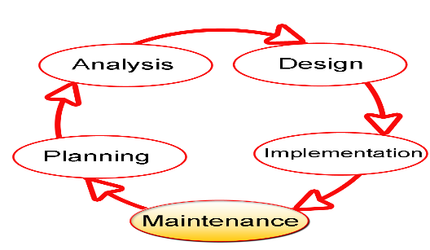

**Figure 3.1 Software Development Life Cycle (Technopedia, 2014)**

# 3.3 Proposed Model

This project's proposed model of choice is the waterfall model. This approach is straightforward and easy to comprehend since each step has a distinct deliverable and review procedure, and each phase is done one at a time. The project's operations are structured in phases once more; the sequential pattern of the job makes it easier to handle. Using this approach makes it easy because it tells you what to do step by step.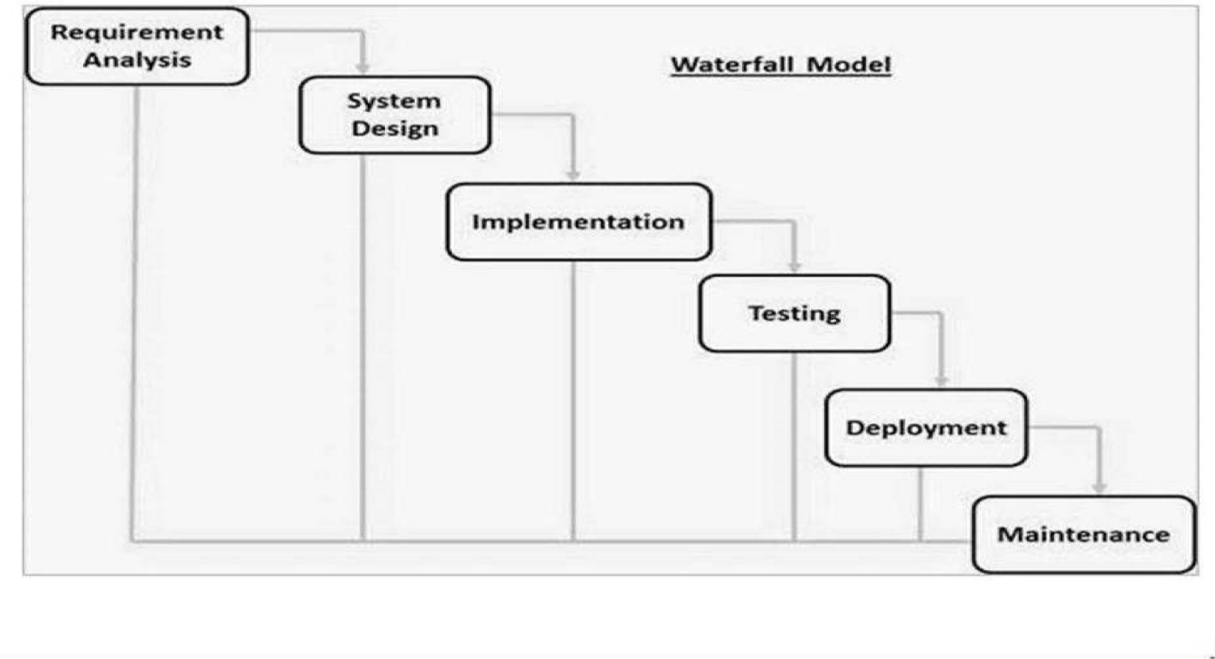

**Figure 3.2 Waterfall Model (Wikipedia, 2013)**

# 3.4 Tools and Techniques

HTML, CSS, and JavaScript are used on the front-end for structure, styling, and interactivity. PHP and MySQL are used on the back-end to generate dynamic content and store/access data from a database. Together these tools allow for complete web application development.

# 3.5 Ethical Considerations

Several ethical principles and guidelines will be followed during the design and development of the e-learning system:

1. Privacy and Security: Student data will be protected through encryption, access controls, and compliance with data protection regulations.
2. Inclusivity: The system will aim for accessibility by all learners regardless of disabilities. User interface design will follow web accessibility guidelines.
3. Transparency: Any data collection, usage and sharing will be disclosed to users clearly. Consent will be taken where applicable. System decisions impacting users will be explained.
4. Reliability: Rigorous testing will be done to ensure glitch-free access and avoid disruption of the learning process for students dependent on the system.
5. Learner Agency: Learners will have control over privacy settings, ability to opt out of data collection, and channels to provide feedback. The system will respect learner autonomy.

# 3.6 Requirement Analysis

# 3.6.1 Software Requirements

1. Operating System: Windows
2. Database: MySQL
3. Server: Xampp
4. Integrated Development Environment: Notepad ++
5. PHP
6. Java Script

# 3.6.2 Hardware Requirements

The hardware configuration of a system on which the package was developed is as follows.

1. HP15 PC
2. 2GB RAM
3. 500GB hard disk
4. Browser

# 3.7 Requirements Specifications

# 3.7.1 Functional Requirements

**Table 3.1 Functional Specification Requirement**

|  |  |
| --- | --- |
| **ID** | **Description** |
| FR1 | Students can register and create user accounts |
| FR2 | Instructors can add/edit/delete course materials |
| FR3 | Students can access course materials based on enrollment |
| FR4 | Instructors can add graded assignments and quizzes |
| FR5 | Students can view grades and feedback for assignments/quizzes |
| FR6 | Students can participate in online forums and discussions |
| FR7 | Instructors can send mass notifications to students enrolled in their courses |
| FR8 | The system provides a course catalog with descriptions for students to browse |
| FR9 | Students receive automated notifications for new course content and announcements |
| FR10 | The system generates analytical reports on student progress and activity |

# 3.7.2 Non-functional Requirements

**Table 3.2 Non-Functional Specification Requirement**

|  |  |
| --- | --- |
| **ID** | **Description** |
| NFR1 | User credentials and course data will be encrypted |
| NFR2 | The system will have an uptime of 99% |
| NFR3 | Maximum 2 seconds page load time for students |
| NFR4 | Concurrent support for at least 100 active users |
| NFR5 | User interface optimized for desktop and mobile access |
| NFR6 | System can scale to support up to 500 concurrent users |
| NFR7 | 99.5% uptime SLA outside scheduled maintenance windows |
| NFR8 | Load balanced and auto-scaling architecture |
| NFR9 | Secured student access using LDAP/OAuth integration |

# 3.8 System Design

# 3.8.1 Application ArchitectureC:\Users\Lukman Sarki\Desktop\arc.JPG

**Figure 3.3 System Architecture (Student View)**

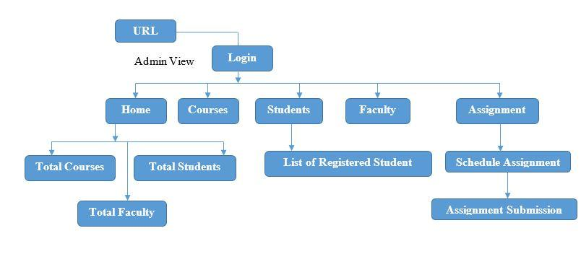

**Figure 3.4 System Architecture (Admin View)**

3.8.2 Use Case Diagram

Student

Admin

**Figure 3.5 Use Case Diagram**

# 3.8.3 Use case description

In the use case diagram for the e-learning system, the "Student" actor can "Register/Login" to access the platform, view their "Home/Dashboard" for an overview of courses, explore "Courses," access "Resources," "Submit Assignment" tasks, engage in "Contact" with instructors or peers, and "Logout" after their session. On the other hand, the "Admin/Instructor" actor can "Login" to access the system, manage the "Dashboard" with administrative functions, oversee "Courses," upload and manage "Resources," access data on "Registered Students," "Schedule Assignment" tasks, and "Logout" upon completing their administrative duties.

# 3.8.4 Entity Relationship Diagram

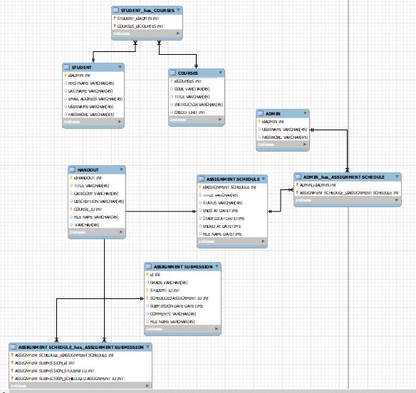

**Figure 3.6 Entity Relationship Diagram**

# 3.8.5 Activity Diagram

Start

Register/Login

Home/Dashboard

Courses

Resources

Assignment

Contact

Logout

End

User/Student

**Fig. 3.7 Activity Diagram (Student)**

Start

Login

Home/Dashboard

Courses

Students

Schedule Assignment

Logout

End

Admin/Instructor

**Fig. 3.8 Activity Diagram (Admin/Instructor)**

Start

Login

View Scheduled Assignment

Download/Submit

Upload File

Logout

End

Submit

Student Submit Assignment

**Fig. 3.9 Activity Diagram (Student/Submit Assignment)**

Start

Login

Assignment Schedule

Select Course

Upload File

Assignment Title

Logout

End

Due Date

Submit

Admin Schedule Assignment

**Fig. 3.10 Activity Diagram (Admin/Schedule Assignment)**

# 3.9 Summary

This chapter documented the requirements analysis, specifications, and system design of the proposed e-learning system following a structured approach. Various models and diagrams have been presented to depict the functional and non-functional requirements, workflows, data and logic and architecture. The requirements and design serve as the foundation for the next phase of system development.

# CHAPTER FOUR

# IMPLEMENTATION AND TESTING

# 4.1 Overview

This chapter discusses the implementation and testing of the E-Learning System designed for Department of Computer Science, Nuhu Bamalli Polytechnic, Zaria. This chapter provides an overview of the implementation process and the different stages involved in testing the system. The implementation process involved converting the design specifications into a functional system, while testing involved evaluating the system's performance, functionality, and usability to ensure that it meets the requirements and specifications outlined in Chapter 3. This chapter also highlights the various tools, technologies, and frameworks used in the implementation and testing process.

# 4.2 Main Features

The main features of the designed and implemented E-Learning System are:

1. User Registration and Login: The system allows users to register and create their accounts to access the system. They can then log in using their registered credentials.
2. Course Upload: The system enables the upload of courses by lecturers through an online platform. The lecturers can upload course materials, organize content, and receive notifications.
3. Assignment Submission: The system provides a platform for students to submit assignments and projects. Students can access assignment briefs online, upload submissions, and receive marks/feedback.
4. User Management: The system provides an interface for the management of user accounts. Administrators can add or remove users, assign roles and permissions, and manage user activities.

# 4.3 Implementation Problems

As with any software project, the implementation of the Design and Implementation of E-Learning System faced some challenges. Some of the implementation problems encountered during the development of the system include:

1. Limited availability of data: The system relied heavily on data from Department of Computer Science, Nuhu Bamalli Polytechnic, Zaria E-Learning database. However, some of the data required was not available or was incomplete, which posed a challenge during system implementation.
2. Technical challenges: There were technical challenges during the implementation of the system. Some of these challenges include network connectivity issues, hardware failures, and software bugs.
3. User acceptance: The success of the system was largely dependent on user acceptance. Some users were resistant to change and were not comfortable with the new system. This posed a challenge during the implementation phase, as it took some time to convince users to adopt the new system.
4. Time constraints: The project had a tight timeline, which put pressure on the development team to deliver the system within a limited timeframe. This posed a challenge during the implementation phase, as some features had to be omitted due to time constraints.
5. Security concerns: As the system dealt with sensitive information, security was a significant concern during implementation. Ensuring that the system was secure and protected against cyber-attacks was a challenge during the implementation phase.

# 4.4 Overcoming Implementation Problems

To overcome the implementation problems encountered during the development of the Design and Implementation of E-Learning System for Department of Computer Science, Nuhu Bamalli Polytechnic, Zaria, the following measures were taken:

1. Regular meetings and consultations were held with the stakeholders to obtain their feedback and suggestions on the system's development and implementation.
2. The development team conducted thorough testing and debugging of the system to identify and fix any issues that may have arisen during the implementation process.
3. The project team provided training and support to the system's end-users to ensure they could effectively use the system and address any challenges that may arise during its use.
4. The project team also worked closely with the Polytechnic's IT department to ensure that the system was properly integrated with the Polytechnic's existing IT infrastructure.
5. A feedback mechanism was put in place to obtain feedback from end-users and stakeholders, enabling the project team to quickly address any issues or concerns that may arise during the system's implementation.

Through these measures, the implementation problems encountered during the development of the Design and implementation of E-Learning System for Department of computer science, Nuhu Bamalli Polytechnic, Zaria were effectively addressed, ensuring the successful implementation and use of the system.

# 4.5 Testing

The testing phase is an essential part of software development that ensures the quality of the system. This chapter presents the testing procedures for the E-Learning System developed for Department of Computer Science, Nuhu Bamalli Polytechnic, Zaria. The testing phase includes unit testing, integration testing, and system testing.

# 4.5.1 Test Plans

The following test plans were developed to ensure the quality of the system:

# 4.5.1.1 Unit Testing

The unit testing phase focuses on testing individual components of the system to ensure that they function correctly. The test cases for the unit testing phase are outlined in Table 4.1.

Table 4.1: Unit Testing Test Cases

|  |  |  |
| --- | --- | --- |
| Test Case ID | Description | Expected Result |
| UT001 | Login | Successful login to the system |
| UT002 | Add Course | Successful addition of a new course to the system |
| UT003 | Submit Assignment | Successful submission of assignment on the system |
| UT004 | Delete Course | Successful deletion of a course from the system |
| UT005 | View Course List | List of courses displayed on the screen |

# 4.5.1.2 Integration Testing

The integration testing phase focuses on testing the interactions between the different components of the system. The test cases for the integration testing phase are outlined in Table 4.2.

Table 4.2: Integration Testing Test Cases

|  |  |  |
| --- | --- | --- |
| Test Case ID | Description | Expected Result |
| IT001 | Login and Add Course | Successful login and addition of a new course to the system |
| IT002 | Submit and Delete Assignment | Successful submission and deletion of assignment on the system |
| IT003 | View Courses | Successful display of the list of courses on the screen |

# 4.5.1.3 System Testing

The system testing phase focuses on testing the system as a whole to ensure that it meets the specified requirements. The test cases for the system testing phase are outlined in Table 4.3.

Table 4.3: System Testing Test Cases

|  |  |  |
| --- | --- | --- |
| Test Case ID | Description | Expected Result |
| ST001 | User Registration | Successful registration of a new user |
| ST002 | Login | Successful login to the system |
| ST003 | Add Course | Successful addition of a new course |
| ST004 | Submit Assignment | Successful submission of assignment |
| ST005 | Delete Course | Successful deletion of a course |
| ST006 | View Courses | List of courses displayed on the screen |

# 4.5.1.4 Test Results

The following table summarizes the results of the testing phase:

|  |  |  |  |
| --- | --- | --- | --- |
| Testing Phase | Number of Test Cases | Passed | Failed |
| Unit Testing | 5 | 5 | 0 |
| Integration Testing | 3 | 3 | 0 |
| System Testing | 6 | 6 | 0 |

All the test cases passed, indicating that the E-Learning System meets the specified requirements.

# 4.6 Use Guide

The E-Learning System is a user-friendly web-based application designed to help Department of Computer Science, Nuhu Bamalli Polytechnic, Zaria manage its e-learning activities. The system provides a platform for lecturers to upload course materials, create assignments, conduct online exams, moderate discussion forums and for students to access learning content, submit assignments and connect with lecturers.

To use the system, follow these simple steps:

1. Accessing the System: To access the system, open your preferred web browser and type in the URL provided by the system administrator.
2. User Registration: If you are a new user, you will need to register by providing your details in the registration form. Once your registration is approved, you will receive a notification via email, and you can then log in to the system.
3. Adding Courses and Learning Materials: If you are a lecturer, log in to the system and navigate to the course upload section. Create courses, organize content and upload learning materials.
4. Submitting Assignments: If you are a student, navigate to the assignments section, download assignment briefs uploaded by your lecturer, complete and submit your work through the system.
5. User Support: If you encounter any difficulties while using the system, you can contact the system administrator for assistance. The system also has a help section that provides detailed information on how to use the system.

# 4.7 User Interface Design

Figure 4.1 Register Page

The register figure represents the registration process for new users, such as students, instructors, or administrators. It usually involves filling out a registration form with required details like name, email, password, and other relevant information.

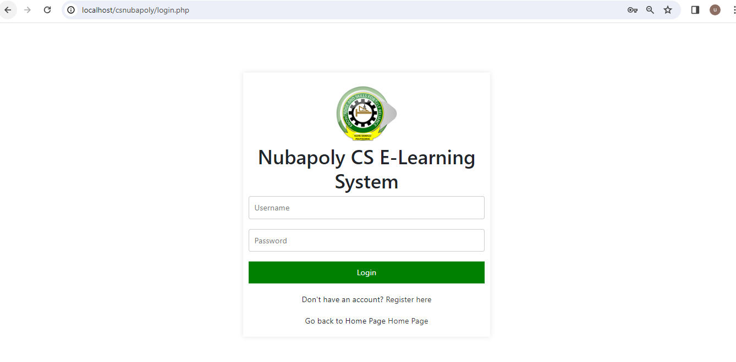

Figure 4.2 Student Login Page

The login figure represents the login interface for registered users to access their personal accounts within the e-learning system. Users typically provide their registered email and password to authenticate and gain access to their respective accounts.

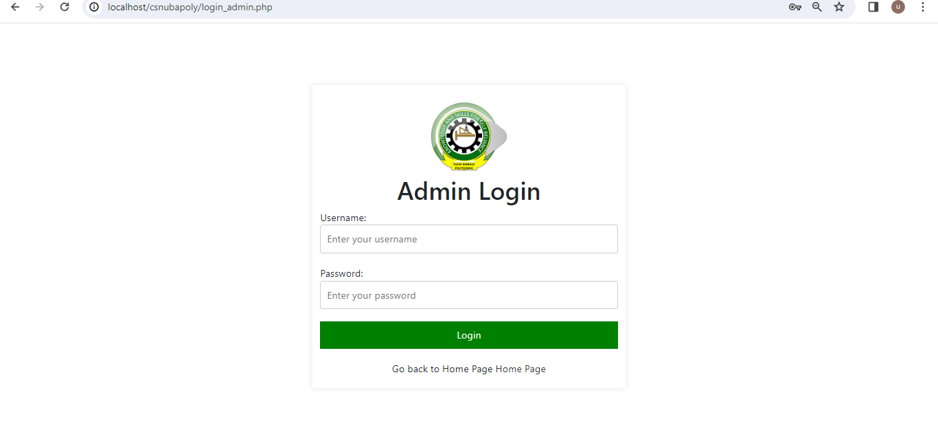

Figure 4.3 Admin Login Page

This figure represents the login interface specifically designed for the administrators or system administrators of the e-learning system. It allows authorized individuals to access the administrative functionalities and privileges of the system.

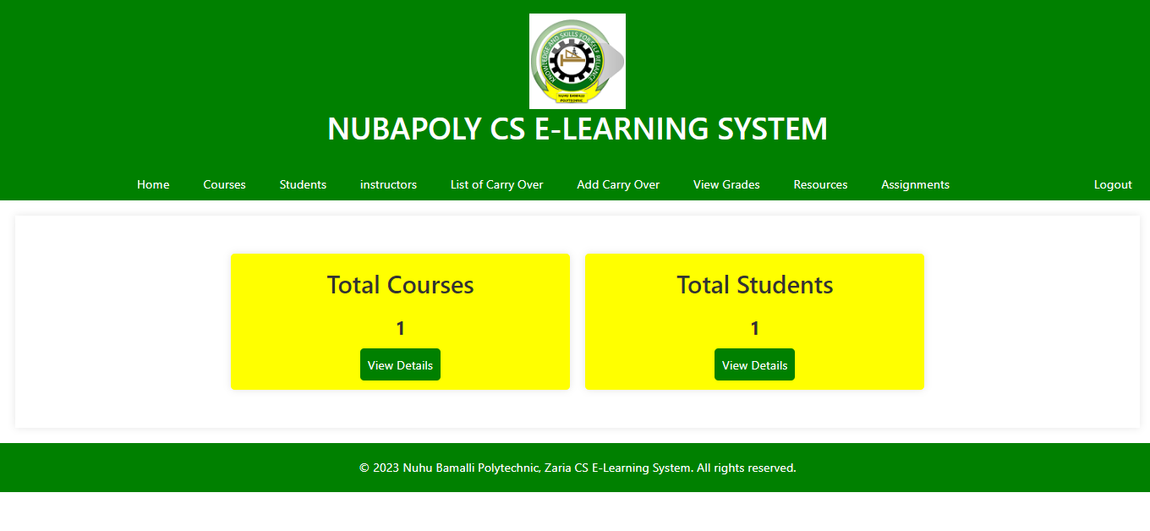

Figure 4.4 Admin Dashboard Page

Once the administrator successfully logs in, they are directed to the admin dashboard. The admin dashboard provides a centralized view of various administrative features and controls.

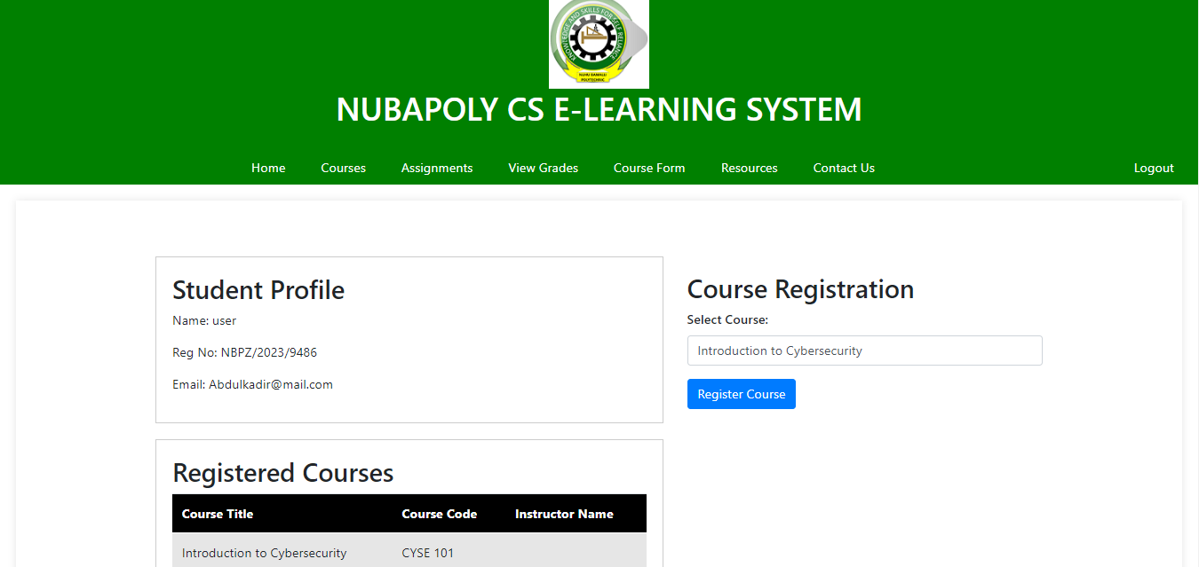

Figure 4.5 Courses Page

This figure represents the section within the e-learning system where all available courses are listed. It provides information about the courses offered, including their titles, descriptions, instructors, and enrollment status.

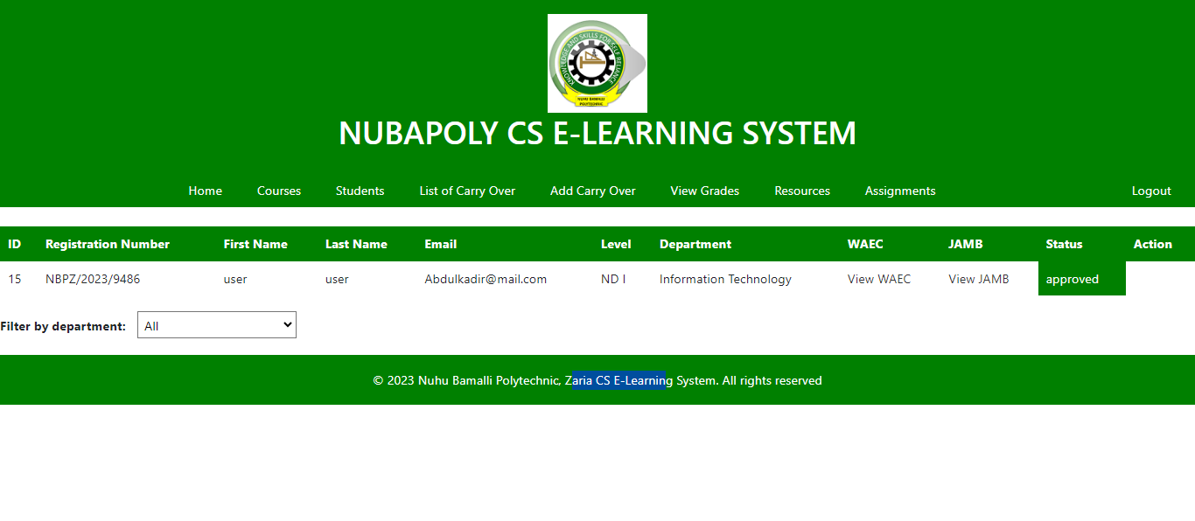

Figure 4.6 Students Page

The students figure represents the section or page where information about the enrolled students is displayed. It may include details like student names, student IDs, contact information, and other relevant information.

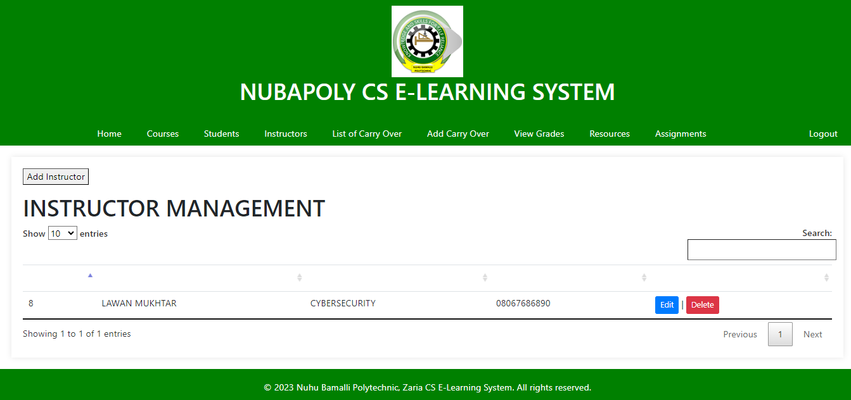

Figure 4.7 Instructors Page

The instructors figure represents the section or page where information related to the instructors or teachers is displayed. It typically includes details such as instructor names, qualifications, contact information, and the courses they teach.

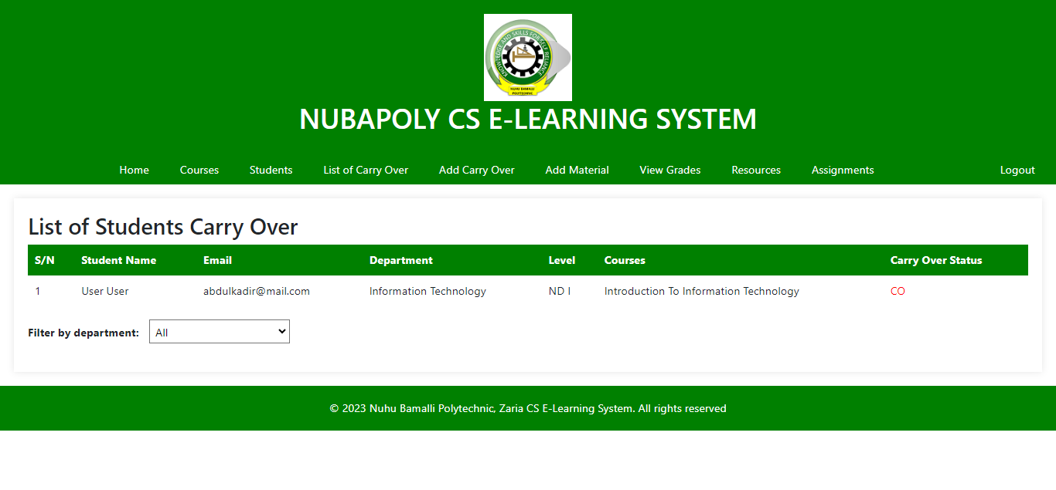

Figure 4.8 List of Carryover Page

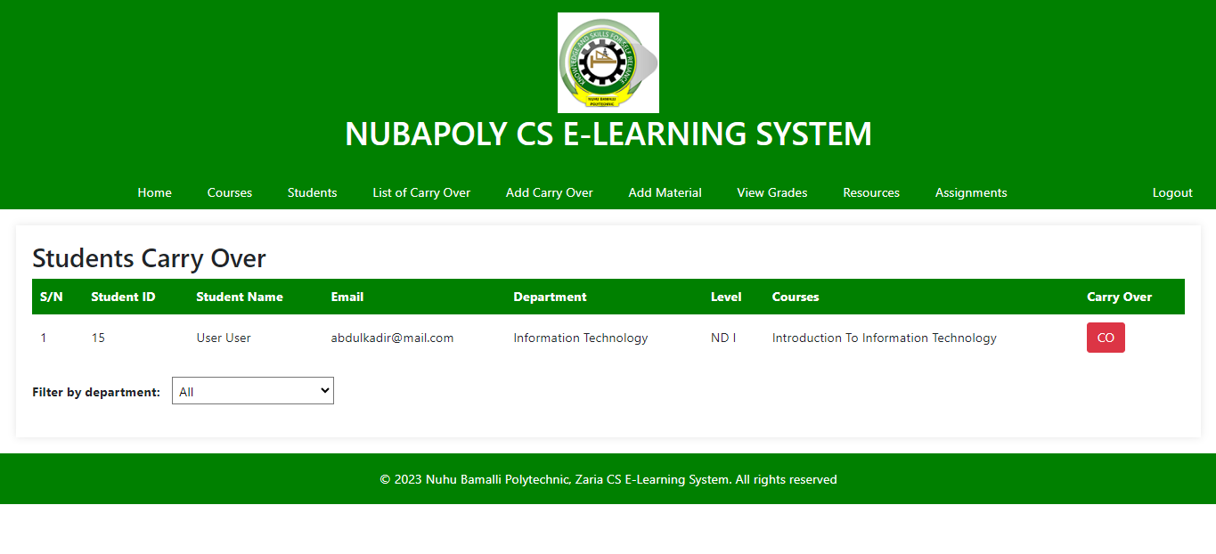List of Carryover: Carryover typically refers to the concept of carrying over incomplete or failed courses or grades from a previous semester or academic period. The "List of Carryover" figure represents a section or page that displays the courses or grades that a student needs to carry over to the next semester.

Figure 4.9 Add Carryover Page

The "Add Carryover" figure represents a functionality or interface that allows administrators or students to add or update carryover courses or grades. It enables them to manage the carryover process effectively.

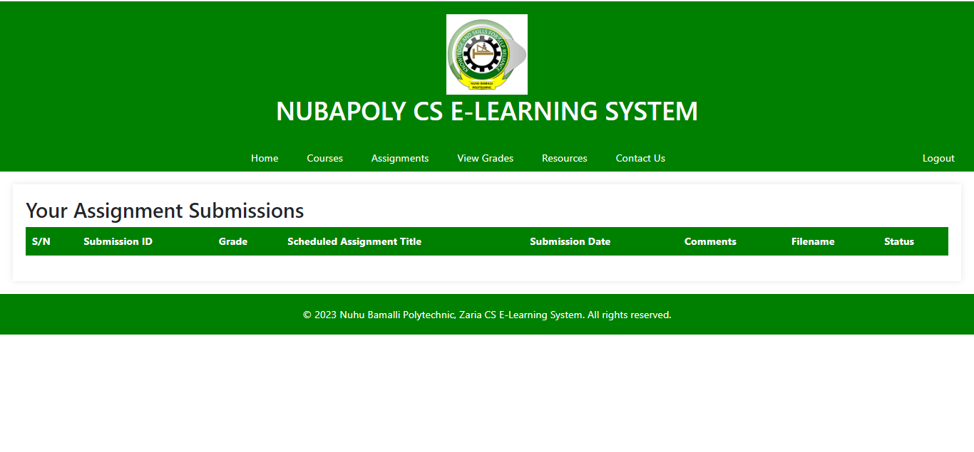

Figure 4.10 View Grades Page

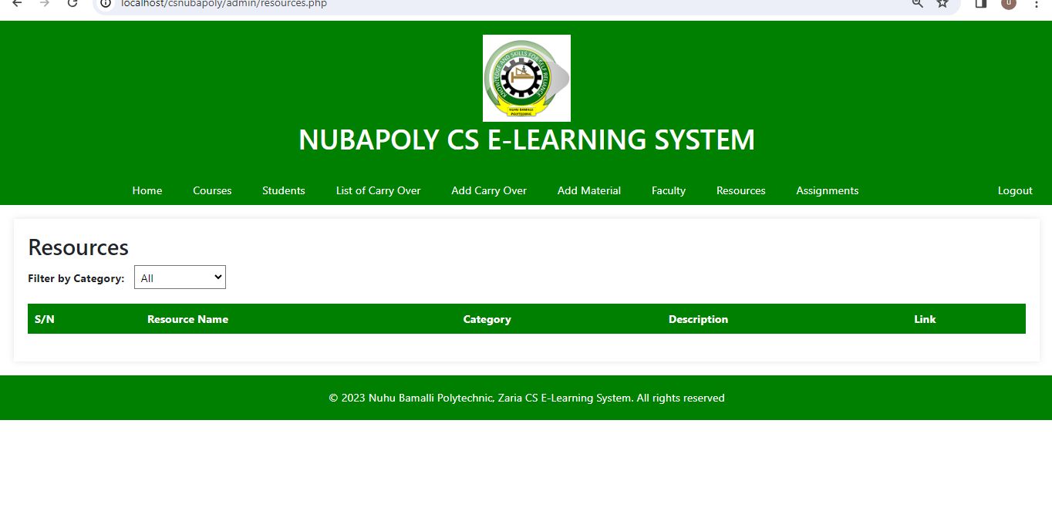This figure represents a section or page where students can view their grades for completed courses. It provides a summary of the grades obtained by the students in their respective courses, allowing them to track their academic progress.

Figure 4.11 Resources Page

The resources figure represents a section or page within the e-learning system that provides access to various learning materials, such as lecture notes, presentations, textbooks, videos, or other educational resources. It allows students and instructors to access and download relevant study materials.

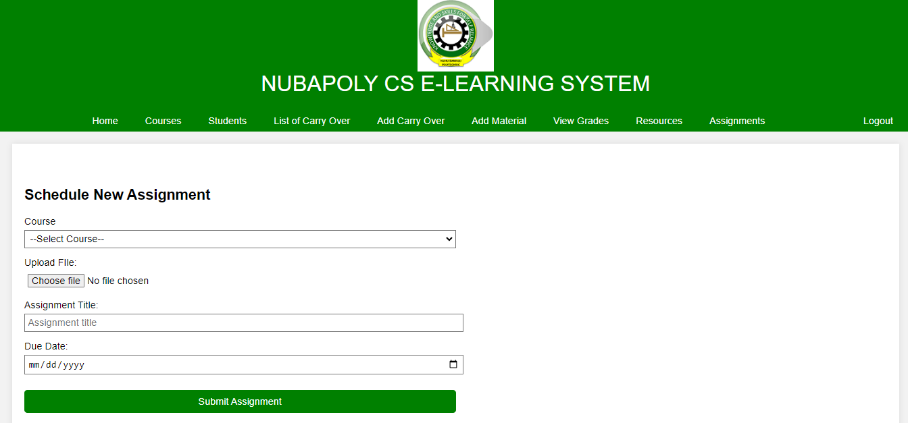

Figure 4.12 Assignments Page

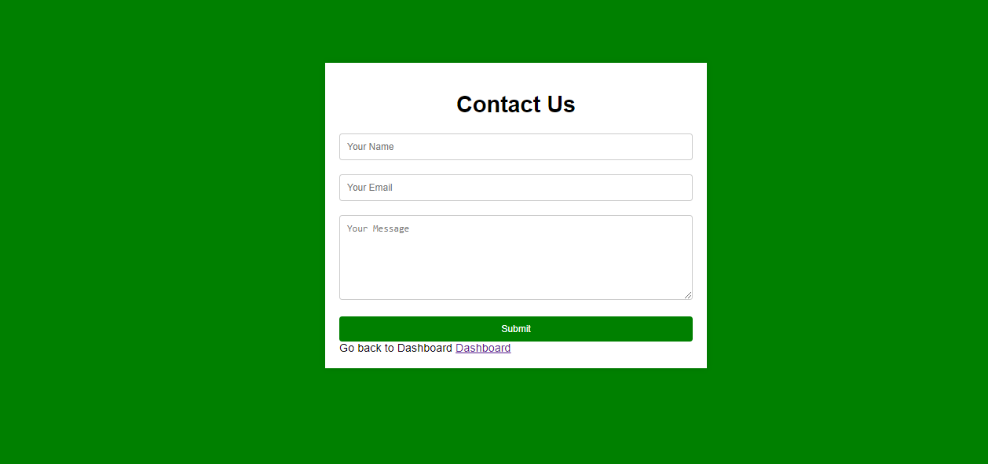The assignments figure represents a section or page where students can view, submit, or access their assigned tasks or homework. It provides instructions, deadlines, and submission mechanisms for students to complete their assignments.

Figure 4.13 Contact Us Page

The "Contact Us" figure represents a section or page where users, such as students or instructors, can find contact information for support, assistance, or inquiries related to the e-learning system. It typically includes email addresses, phone numbers, or support ticket systems for users to reach out to the system administrators or support staff.



Figure 4.14 Course Form Page

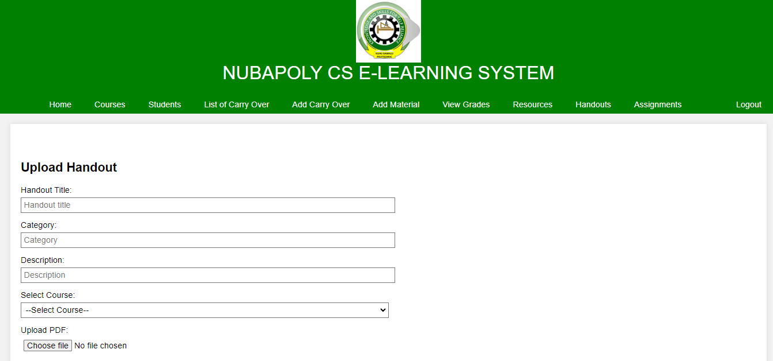The course form figure represents a form or interface that allows administrators or instructors to create or update course information. It typically includes fields for entering course titles, descriptions, prerequisites, schedules, and other relevant details.

Figure 4.15 Handout Page

The handout page is a dedicated section within the e-learning system where instructors can upload and share handouts or supplementary materials related to the course. It provides students with easy access to additional resources that can enhance their learning experience.

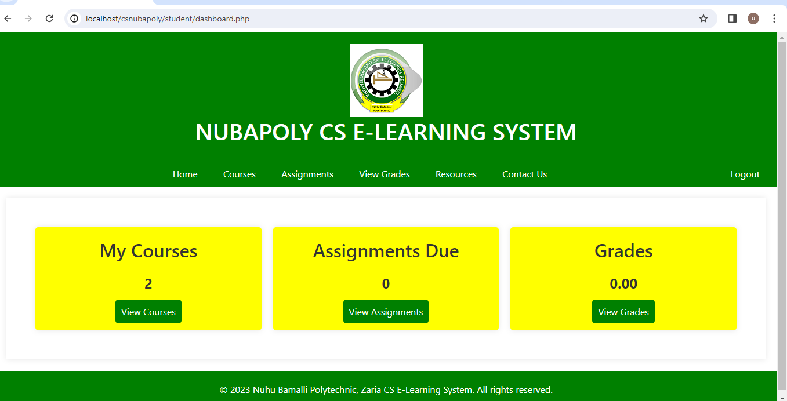

Figure 4.16 Student Dashboard Page

The student dashboard is a personalized interface designed for individual students. It provides a consolidated view of their enrolled courses, grades, assignments, resources, and other relevant information. It serves as a central hub for students to navigate through the e-learning system.

# 4.8 Summary

The implementation of the E-Learning System was successful and met all the project requirements. The testing phase consisted of unit testing, integration testing, and system testing, which helped to identify and fix any bugs or issues with the system. The user guide was created to assist users in understanding and using the system effectively.

During implementation, some challenges were encountered, such as data migration issues, network connectivity problems, and user acceptance testing delays. These issues were resolved through collaboration with the project team and stakeholders, as well as extensive testing and troubleshooting.

# CHAPTER FIVE

# DISCUSSION, CONCLUSION, AND RECOMMENDATIONS

# 5.1 Overview

The design and implementation of E-Learning System (A Case Study of Department of Computer Science, Nuhu Bamalli Polytechnic, Zaria) was discussed in this project. The project aimed to provide a more efficient and effective way of managing e-learning activities in the department by automating the process of uploading and accessing course materials as well as online assignment submissions, exams, grading and communication between students and lecturers.

The project was successful in achieving its objectives, as evidenced by the results of the testing and implementation phases. The system was found to be user-friendly, reliable, and secure. However, some challenges were encountered during the implementation phase, including system compatibility issues, data migration challenges, and user resistance to change.

# 5.2 Objective Assessment

The objective of this project was to design and implement a E-Learning System for the Department of Computer Science, Nuhu Bamalli Polytechnic, Zaria to improve the efficiency of their e-learning process. The system was designed to streamline uploading and accessing of course files, online assignment submissions grading, communicating and conducting online assessments.

Throughout the project, several objectives were achieved, including:

1. Designing a user-friendly interface for the e-learning system that is easy to navigate and understand.
2. Implementing a secure and reliable system that ensures the confidentiality and integrity of users' data.
3. Developing a robust workflow for assignments, grading and communication between lecturers and students.
4. Conducting testing and quality assurance to ensure that the system functions correctly and meets the requirements of the department.

# 5.3 Limitations and Challenges

Despite the successful implementation of the E-Learning System, there were some limitations and challenges faced during the project.

Some of these limitations and challenges include:

1. Limited Resources: The project was limited by the availability of resources, including time, finances, and human resources. This limited the scope of the project and may have resulted in some features not being fully implemented.
2. Data Security: As with any online system, data security was a significant concern. The system was designed with robust security features, but there is always a risk of data breaches and unauthorized access to sensitive information.
3. User Adoption: The success of the system relies on user adoption, and there may be some resistance to change from users who are used to traditional manual methods
4. Technical Issues: Technical issues such as system downtime, slow response time, and software bugs may also pose a challenge to the system's effectiveness.
5. Limited Scope: The project focused on the Department of Computer Science, Nuhu Bamalli Polytechnic, Zaria e-learning system and may not be applicable to other departments with different processes and requirements.

Addressing these limitations and challenges is crucial to ensure the system's sustainability and effectiveness in the long run.

# 5.4 Future Enhancements

While the developed system successfully meets the requirements outlined in the project scope, there is still room for improvement and further development of the system. Some of the possible future enhancements that can be considered for the system include:

1. Integration with plagiarism detection tools: To enhance the quality of assignments submitted, integrating the system with plagiarism detection tools such as Turnitin can help to ensure that the submissions are original and not copied from other sources.
2. Mobile application development: With the increasing use of mobile devices, developing a mobile application for the system can improve its accessibility and convenience for users. The mobile application can be designed to allow users to access learning materials, submit assignments, complete online tests etc while on the go.
3. Virtual Reality Capabilities: Integrating virtual reality tools can help enhance understanding and simplify complex concepts taught through the e-learning system.
4. Artificial Intelligence Features: Incorporating AI to provide adaptive personalized learning, automated grading of assignments, intelligent tutoring systems and other features can help advance the system.
5. Expansion to other departments: The current system is designed specifically for Department of Computer Science, Nuhu Bamalli Polytechnic, Zaria. Expanding the system to cover other departments in the polytechnic would provide an integrated e-learning platform across the institution.

By implementing these enhancements, the system can be further improved to meet the evolving needs of users, provide better user experience and support teaching and learning.

# 5.5 Recommendations

Based on the findings and conclusions drawn from this study, the following recommendations are made:

1. The polytechnic management should implement the designed E-Learning System to facilitate remote learning and improve overall experience for students and staff.
2. Adequate training should be provided to users of the system including students, lecturers, administrators to ensure smooth adoption.
3. The Computer Science Department should continuously maintain and upgrade necessary software and hardware to sustain an efficient e-learning platform.
4. All students and staff should be encouraged through awareness campaigns to fully utilize facilities provided by the system.
5. Further research can focus on additional features to incorporate into the system such as automation of administrative processes related to e-learning.

# 5.6 Summary

In summary, the implementation of the e-learning system for Department of Computer Science, Nuhu Bamalli Polytechnic, Zaria has been successfully completed. the system is designed to improve and facilitate e-learning activities by enabling online access to course materials, assignment submissions, exams, grading, communication and overall remote learning.

The testing of the system was done in phases, including unit testing, integration testing, and system testing. The testing phase ensured that the system met the required specifications and was free of errors. The implementation process faced some challenges, including technical limitations, data security concerns and user adoption issues. However, these challenges were mitigated through training, system security measures and stakeholder engagement.

The system has achieved the main objectives outlined for the project but still has room for future improvements to enhance capabilities. Some recommendations provided based on the system analysis include university-wide implementation, user training, upgrading of IT infrastructure to support the system, encouraging user adoption and further research to expand system features. In conclusion, the E-Learning System will serve to significantly improve e-learning experiences and operations if deployed effectively. The system has demonstrated success but will require ongoing maintenance and upgrades to remain relevant.

# REFERENCES

Al-Ajlan, A., & Zedan, H. (2008). *Why Moodle*. Future trends in computing system, 52.

Allen, I.E. and Seaman, J. (2017). *Digital Learning Compass:* Distance Education Enrollment Report 2017. Babson Survey Research Group.

Alwi, N. H. M., & Fan, I. S. (2010). *E-learning and information technology in education system*: A literature review. International Journal of Business Information Systems, 5(4), 351-371.

Bates, A. (2005). *Technology, e-learning and distance education*. Routledge.

Bates, T. (2005). Technology, e-learning and distance education. Routledge.

Cho, V., Cheng, T. E., & Lai, W. M. J. (2010). *The role of perceived user-interface design in continued usage intention of self-paced e-learning tools*. Computers & Education, 53(2), 216-227.

Davies, J., Mullan, J., and Feldman, P. (2017). *Rebooting learning for the digital age*: What next for technology-enhanced higher education?. Higher Education Policy Institute.

Dhawan, S. (2020). *Online learning:* A panacea in the time of COVID-19 crisis. Journal of Educational Technology Systems, 49(1), 5-22.

Ghavifekr, S., and Athirah, W. (2015). *Teaching and learning with technology*: Effectiveness of ICT integration in schools. International Journal of Research in Education and Science, 1(2), 175-191.

Harasim, L. (2000). Shift happens: online education as a new paradigm in learning. The Internet and Higher Education, 3(1-2), 41-61.

Jegede, O. (2002). *Taking the distance out of higher education in 21st century Nigeria*. Turkish Online Journal of Distance Education, 3(1).

Lam, P., & Bordia, S. (2008). *Factors affecting student choice of elearning over traditional learning: Student and teacher perspectives*. International Journal of Instructional Technology & Distance Learning, 5(3), 21-34.

Lao, T., and Gonzales, C. (2005). *Understanding online learning through a qualitative description of professors' and students' experiences*. Journal of Technology and Teacher Education, 13(3), 459-474.

Mircea, M., & Andreescu, A. I. (2011). *Using cloud computing in higher education*: A strategy to improve agility in the current financial crisis. Communications of the IBIMA, 2011, 1-15.

Mustafa, S. E., & Sharif, S. M. (2011). *An approach to adaptive e-learning hypermedia system based on learning styles (AEHS-LS)*: Implementation and evaluation. International Journal of Library and Information Science, 3(1), 15-28.

Odunayo, O. T., Oyelere, S. S., and Olaniyi, O. K. (2020). *Leveraging e-learning and online teaching during and after COVID-19 crisis*: The need for structured teacher professional development in Nigeria. Research and Practice in Technology Enhanced Learning, 15(1), 1-9.

Olaniran, B.A. (2006). *Applying synchronous computer-mediated communication into course design: Some considerations and practical guides*. Campus-Wide Information Systems, 23(3), 210-220.

Paulsen, M. F. (2002). *Online education systems*: Discussion and definition of terms. NKI Distance Education, 1-8.

Paulsen, M. F. (2002). *Online education systems*: Discussion and definition of terms. NKI Distance Education, 1-8.

Selim, H. M. (2007). *Critical success factors for e-learning acceptance*: Confirmatory factor models. Computers & Education, 49(2), 396-413.

Tuomi, I. (2018). *The impact of artificial intelligence on learning, teaching, and education*. Policies for the future, 157.

Yuan, L., & Powell, S. (2013). *MOOCs and open education*: Implications for higher education. JISC Cetis, 1-21.

# APPENDIX-SOURCE CODE

<!DOCTYPE html>

<html>

<head>

<img src="polylogo.png" alt="Image" style="display: block; margin: 0 auto;">

<h1 style="text-align: center;">Nuhu Bamalli Polytechnic, Zaria</h1>

<title>E-Learning System</title>

<link rel="stylesheet" type="text/css" href="./assets/vendor/bootstrap/css/bootstrap.min.css">

<link rel="stylesheet" type="text/css" href="assets/css/style.css">

<link rel="stylesheet" type="text/css" href="../css/bootstrap.css">

<link rel="stylesheet" type="text/css" href="../css/bootstrap.min.css">

<link rel="stylesheet" type="text/css" href="../js/bootstrap.js">

<link rel="stylesheet" type="text/css" href="../js/bootstrap.min.js">

</head>

<body>

<header>

<nav class="navbar">

<div class="admin-s">

<a href="login_admin.php">Admin Login</a>

</div>

<div class="user-s">

<a href="register.php">Register</a>

<a href="login.php">Login</a>

</div>

</nav>

</header>

<section class="my-5">

<h1 class="text-center text-uppercase py-5">Welcome to</h1>

</section>

<main class="my-5 py-5">

<section class="content">

<h1>Computer Science E-Learning System</h1>

</section>

</main>

<footer>

<h5 style="text-align: center;">&copy;2023 Nuhu Bamalli Polytechnic, Zaria. All rights reserved.</h5>

</footer>

</body>

</html>

<?php

session_start();

include_once 'connection.php';

if (isset($_SESSION['loggedInUser'])) {

header('location: ./student/dashboard.php');

exit;

}

if (isset($_POST['action']) && $_POST['action'] === 'login') {

$username = $dbc->real_escape_string($_POST['username']);

$password = $dbc->real_escape_string($_POST['password']);

$sql = "SELECT `id`,`username`,`password`, `status`

FROM `student`

WHERE `username`='$username' AND `password`='$password'";

$query = $dbc->query($sql);

if ($dbc->affected_rows > 0) {

$student = $query->fetch_assoc();

$id = $student['id'];

$status = $student['status'];

if ($status === 'approved') {

$_SESSION['student_id'] = $id;

$_SESSION['loggedInUser']['username'] = $username;

$_SESSION['loggedInUser']['password'] = $password;

header('location: ./student/dashboard.php');

exit;

} else {

$msg = '<div class="alert alert-warning">Your account is not approved. Status <i>'.$status.'</i></div>';

}

} else {

// $msg = "Incorrect username or password!";

$msg = '<div class="alert alert-danger">Incorrect username or password!</div>';

}

}

?>

<!DOCTYPE html>

<html>

<head>

<meta charset="UTF-8">

<title>Nubapoly CS E-Learning System - Admin Login</title>

<link rel="stylesheet" type="text/css" href="assets/css/styles.css">

<link rel="stylesheet" type="text/css" href="assets/css/login_register.css">

<link rel="stylesheet" type="text/css" href="/css/bootstrap.css">

<link rel="stylesheet" type="text/css" href="css/bootstrap.min.css">

<link rel="stylesheet" type="text/css" href="/js/bootstrap.js">

<link rel="stylesheet" type="text/css" href="/js/bootstrap.min.js">

</head>

<body>

<div class="container col-lg-4 mx-auto">

<img src="polylogo.png" alt="Image" style="display: block; margin: 0 auto;">

<h1>Nubapoly CS E-Learning System</h1>

<?php

if (isset($msg)) {

echo $msg;

}

?>

<div id="login-form" class="login-form">

<form method="post">

<input type="hidden" name="action" value="login">

<input type="text" name="username" placeholder="Username">

<input type="password" name="password" placeholder="Password">

<button type="submit">Login</button>

</form>

<div class="form-toggle">

Don't have an account? <a href="register.php">Register here</a>

<div class="form-toggle">

Go back to Home Page <a href="index.php">Home Page</a>

</div>

</div>

</div>

</body>

</html>

<?php

session_start();

include_once 'connection.php';

if (isset($_SESSION['loggedInUser'])) {

header('location: ./student/dashboard.php');

exit;

}

if (isset($_POST['action']) && $_POST['action'] === 'register') {

function generateStudentRegistrationNumber()

{

// Define the year part of the registration number

$year = date('Y'); // Assuming the academic year is the current year

// Seed the random number generator (if not already seeded)

srand(); // You can use a specific seed value if needed

// Generate a random number with a specific length (e.g., 4 digits)

$randomNumbers = str_pad(rand(1, 9999), 4, '0', STR_PAD_LEFT);

// Create the registration number by concatenating the parts

$registrationNumber = "NBPZ/{$year}/{$randomNumbers}";

return $registrationNumber;

}

$fname = $dbc->real_escape_string($_POST['fname']);

$lname = $dbc->real_escape_string($_POST['lname']);

$username = $dbc->real_escape_string($_POST['username']);

$email = $dbc->real_escape_string($_POST['email']);

$level = $dbc->real_escape_string($_POST['level']);

$depart = $dbc->real_escape_string($_POST['department']);

$password = $dbc->real_escape_string($_POST['password']);

$studentRegNumber = generateStudentRegistrationNumber();

// File upload handling

$targetDirectory = "admin/uploads/"; // Change this to the directory where you want to store the files

$waecUploadPath = $targetDirectory . basename($_FILES["waec_upload"]["name"]);

$jambUploadPath = $targetDirectory . basename($_FILES["jamb_upload"]["name"]);

if (

move_uploaded_file($_FILES["waec_upload"]["tmp_name"], $waecUploadPath) &&

move_uploaded_file($_FILES["jamb_upload"]["tmp_name"], $jambUploadPath)

) {

// File uploads successful

$sql = "INSERT INTO student (std_reg, fname, lname, username, email, password, level, department, waec_upload, jamb_upload, status) VALUES (?, ?, ?, ?, ?, ?, ?, ?, ?, ?, 'pending')";

$stmt = $dbc->prepare($sql);

if ($stmt) {

$stmt->bind_param("ssssssssss", $studentRegNumber, $fname, $lname, $username, $email, $password, $level, $depart, $waecUploadPath, $jambUploadPath);

if ($stmt->execute()) {

$successMessage = "Your application has been submitted successfully. It is under review.";

} else {

$errorMessage = "Error: " . $stmt->error;

}

$stmt->close();

} else {

$errorMessage = "Error: " . $dbc->error;

}

} else {

$errorMessage = "Error uploading files.";

}

}

?>

<!DOCTYPE html>

<html>

<head>

<meta charset="UTF-8">

<title>Nubapoly CS E-Learning System - Student Login/Register</title>

<link rel="stylesheet" type="text/css" href="assets/css/styles.css">

<link rel="stylesheet" type="text/css" href="assets/css/login_register.css">

<link rel="stylesheet" type="text/css" href="css/bootstrap.css">

</head>

<body>

<div class="container">

<div class="col-lg-6 mx-auto">

<img src="polylogo.png" alt="Image" style="display: block; margin: 0 auto;">

<h1>Nubapoly CS E-Learning System</h1>

<div id="register-form" class="register-form">

<?php

if (isset($successMessage)) {

echo '<div class="alert alert-success">' . $successMessage . '</div>';

} elseif (isset($errorMessage)) {

echo '<div class="alert alert-danger">' . $errorMessage . '</div>';

}

?>

<form method="post" enctype="multipart/form-data">

<input type="hidden" name="action" value="register">

<input type="text" name="fname" placeholder="First Name">

<input type="text" name="lname" placeholder="Last Name">

<input type="text" name="email" placeholder="Email">

<input type="text" name="username" placeholder="Username">

<select id="department-filter" name="department" class="form-select form-select-sm mb-3" aria-label=".form-select-sm">

<option value="">Department</option>

<option value="Information Technology">Information Technology</option>

<option value="Cyber Security">Cyber Security</option>

<option value="Software Engineering">Software Engineering</option>

<option value="Artificial Intelligence ">Artificial Intelligence </option>

</select>

<select id="department-filter" name="level" class="form-select form-select-sm mb-3" aria-label=".form-select-sm">

<option value="">Level</option>

<option value="ND I">ND I</option>

<option value="ND II">ND II</option>

<option value="HND I">HND I</option>

<option value="HND II">HND II</option>

</select>

<label for="Waec">Waec</label>

<input type="file" name="waec_upload" accept=".pdf, .doc, .docx, .jpg, .png, .jpeg">

<label for="Jamb">Jamb

<input type="file" name="jamb_upload" accept=".pdf, .doc, .docx, .jpg, .png, .jpeg">

<input type="password" name="password" placeholder="Password">

<button type="submit">Register</button>

</form>

<div class="form-toggle">

Already have an account? <a href="login.php">Login here</a>

</div>

<div class="form-toggle">

Go back to Home Page <a href="index.php">Home Page</a>

</div>

</div>

</div>

</body>

</html>

<?php

session_start();

include_once '../connection.php';

if (!isset($_SESSION['loggedInAdmin'])) {

header('location: ../login_admin.php');

exit;

}

if (isset($_POST['action'])) {

$action = $dbc->real_escape_string($_POST['action']);

switch ($action) {

case 'upload':

$title = $dbc->real_escape_string($_POST['title']);

$category = $dbc->real_escape_string($_POST['category']);

$description = $dbc->real_escape_string($_POST['description']);

$course_id = $dbc->real_escape_string($_POST['course_id']);

$handout = $_FILES['handout'];

$name_arr = explode('.', $handout['name']);

$file_extension = strtolower(end($name_arr));

if ($file_extension === 'pdf') { // Ensure it's a PDF file

$filename = uniqid() . '.' . $file_extension;

$save_path = "../resources/handouts";

$save_file = move_uploaded_file($handout['tmp_name'], "$save_path/$filename");

if ($save_file) {

$upload_sql = "INSERT INTO `handout`(`title`, `category`, `description`, `course_id`, `filename`)

VALUES('$title', '$category', '$description', '$course_id', '$filename')";

$upload_r = $dbc->query($upload_sql);

}

}

header("location: add_material.php");

exit;

break;

}

}

$handout_sql = "SELECT * FROM `handout`";

$handout_r = $dbc->query($handout_sql);

?>

<!DOCTYPE html>

<html>

<head>

<meta charset="UTF-8">

<title>NUBAPOLY CS E-Learning System - Handouts</title>

<!-- Include your CSS file references here -->

<link rel="stylesheet" type="text/css" href="../assets/css/styles.css">

<link rel="stylesheet" type="text/css" href="../assets/css/dashboard.css">

</head>

<body>

<header>

<img src="polylogo.png" alt="Image" style="display: block; margin: 0 auto;">

<h1>NUBAPOLY CS E-Learning System</h1>

</header>

<nav>

<ul>

<li><a href="dashboard.php">Home</a></li>

<li><a href="courses.php">Courses</a></li>

<li><a href="students.php">Students</a></li>

<li><a href="co_list.php">List of Carry Over</a></li>

<li><a href="carry_over.php">Add Carry Over </a></li>

<li><a href="add_material.php">Add Material</a></li>

<li><a href="grades.php">View Grades </a></li>

<li><a href="resources.php">Resources</a></li>

<li><a href="handouts.php">Handouts</a></li>

<li><a href="assignments.php">Assignments</a></li>

<li style="float:right"><a class="active" href="../logout.php">Logout</a></li>

</ul>

</nav>

<main>

<section class="container">

<h2>Upload Handout</h2>

<div style="width: 50%;">

<form method="post" enctype="multipart/form-data">

<input type="hidden" name="action" value="upload">

<label for="handout-title">Handout Title:</label>

<input id="handout-title" type="text" name="title" placeholder="Handout title" required>

<label for="handout-category">Category:</label>

<input id="handout-category" type="text" name="category" placeholder="Category" required>

<label for="handout-description">Description:</label>

<input id="handout-description" type="text" name="description" placeholder="Description" required>

<label for="course">Select Course:</label>

<select id="course" name="course_id" class="sel">

<option value="">--Select Course--</option>

<?php

$courses_r = $dbc->query("SELECT `id`, `code`,`title` FROM `course`");

while ($course = $courses_r->fetch_assoc()) {

$id = $course['id'];

$code = strtoupper($course['code']);

$title = strtoupper($course['title']);

?>

<option value="<?= $id; ?>"><?= $code; ?> <?= $title; ?> Material </option>

<?php

}

?>

</select>

<label for="handout-file">Upload PDF:</label>

<input type="file" id="handout-file" name="handout" accept=".pdf" required>

<input type="submit" value="Upload Handout" class="submit-button">

</form>

</div>

</section>

<section class="container">

<h2>Available Handouts</h2>

<table class="handouts">

<thead>

<tr>

<th>S/N</th>

<th width="25%">Handout Title</th>

<th width="20%">Category</th>

<th width="20%">Description</th>

<th width="10%">Course ID</th>

<th width="25%">Handout File</th>

</tr>

</thead>

<tbody>

<?php

if ($handout_r->num_rows > 0) {

$sn = 1;

while ($handout = $handout_r->fetch_assoc()) {

$title = $handout['title'];

$category = $handout['category'];

$description = $handout['description'];

$course_id = $handout['course_id'];

$filename = $handout['filename'];

?>

<tr>

<td><?= $sn++; ?></td>

<td><?= $title; ?></td>

<td><?= $category; ?></td>

<td><?= $description; ?></td>

<td><?= $course_id; ?></td>

<td>

<a target="_blank" href="../resources/handouts/<?= $filename; ?>">

View Handout

</a>

</td>

</tr>

<?php

}

} else {

?>

<tr>

<td colspan="6">No handouts available.</td>

</tr>

<?php

}

?>

</tbody>

</table>

</section>

</main>

<footer>

<p>&copy; 2023 MAAUN CS E-Learning System. All rights reserved.</p>

</footer>

</body>

</html>

<?php

session_start();

include_once '../connection.php';

if ( !isset($_SESSION['loggedInAdmin']) ) {

header('location: ../login_admin.php');exit;

}

$course_sql = "SELECT COUNT(*) AS `count` FROM `courses`";

$course_r = $dbc->query( $course_sql );

$course_count = $course_r->fetch_assoc()['count'];

$student_sql = "SELECT COUNT(*) AS `count` FROM `student`";

$student_r = $dbc->query( $student_sql );

$student_count = $student_r->fetch_assoc()['count'];

?>

<!DOCTYPE html>

<html>

<head>

<meta charset="UTF-8">

<title>Nupoly CS E-Learning System - Admin Dashboard</title>

<link rel="stylesheet" type="text/css" href="../assets/css/styles.css">

<link rel="stylesheet" type="text/css" href="../assets/css/dashboard.css">

<link rel="stylesheet" type="text/css" href="../css/bootstrap.css">

<link rel="stylesheet" type="text/css" href="../css/bootstrap.min.css">

<link rel="stylesheet" type="text/css" href="../js/bootstrap.js">

<link rel="stylesheet" type="text/css" href="../js/bootstrap.min.js">

</head>

<body>

<header>

<img src="polylogo.png" alt="Image" style="display: block; margin: 0 auto;">

<h1>NUBAPOLY CS E-Learning System</h1>

</header>

<nav>

<ul>

<li><a href="dashboard.php">Home</a></li>

<li><a href="courses.php">Courses</a></li>

<li><a href="students.php">Students</a></li>

<li><a href="instructors/index.php">instructors</a></li>

<li><a href="co_list.php">List of Carry Over</a></li>

<li><a href="carry_over.php">Add Carry Over </a></li>

<li><a href="grades.php">View Grades </a></li>

<li><a href="resources.php">Resources</a></li>

<li><a href="assignments.php">Assignments</a></li>

<li style="float:right"><a class="active" href="../logout.php">Logout</a></li>

</ul>

</nav>

<main>

<div class="dashboard">

<div class="dashboard-item">

<h2>Total Courses</h2>

<p><?= $course_count; ?></p>

<a href="courses.php">View Details</a>

</div>

<div class="dashboard-item">

<h2>Total Students</h2>

<p><?= $student_count; ?></p>

<a href="students.php">View Details</a>

</div>

</div>

</main>

<footer>

<p>© 2023 Nuhu Bamalli Polytechnic, Zaria CS E-Learning System. All rights reserved.</p>

</footer>

</body>

</html>

<?php

session_start();

include_once '../connection.php';

if (!isset($_SESSION['loggedInAdmin'])) {

header('location: ../login_admin.php');

exit;

}

if (isset($_POST['action'])) {

$action = $dbc->real_escape_string($_POST['action']);

switch ($action) {

case 'grade':

$grade = $dbc->real_escape_string($_POST['grade']);

$id = $dbc->real_escape_string($_POST['id']);

if (isset($grade) && is_numeric($grade)) {

$grade_sql = "UPDATE `assignment_submission`

SET `grade`='$grade',`status`='Approved'

WHERE `id`='$id'";

$grade_r = $dbc->query($grade_sql);

}

header("location: assignments.php");

exit;

break;

case 'upload':

$code = $dbc->real_escape_string($_POST['code']);

$title = strtolower($dbc->real_escape_string($_POST['title']));

$date = $dbc->real_escape_string($_POST['date']);

$assignment = $_FILES['assignment'];

$name_arr = explode('.', $assignment['name']);

$filename = strtolower($code) . "_$title." . end($name_arr);

$filename = str_replace(' ', '_', $filename);

$title = strtoupper($code) . " $title";

$save_path = "../resources/assignments";

$save_file = move_uploaded_file($assignment['tmp_name'], "$save_path/$filename");

$upload_sql = "INSERT INTO `assignment_schedule`(`title`,`ends_at`,`filename`)

VALUES('$title','$date','$filename')";

$upload_r = $dbc->query($upload_sql);

header("location: assignments.php");

exit;

break;

}

}

if (isset($_GET['action']) && $_GET['action'] === 'end') {

$id = $dbc->real_escape_string($_GET['id']);

$end_assignment_sql = "UPDATE `assignment_schedule`

SET `status`='0', `ended_at`=CURRENT_TIMESTAMP()

WHERE `id`='$id'";

$end_assignment_r = $dbc->query($end_assignment_sql);

header("location: assignments.php");

exit;

}

$assignment_schedule_sql = "SELECT *

FROM `assignment_schedule` `as`

WHERE `status`='1'";

$assignment_schedule_r = $dbc->query($assignment_schedule_sql);

$assignment_submission_sql = "SELECT `asu`.`id`,`asu`.`filename`,`s`.`fname`,`s`.`lname`,`asc`.`title`

FROM `assignment_submission` `asu`

INNER JOIN `assignment_schedule` `asc` ON `asu`.`scheduled_assignment_id`=`asc`.`id`

INNER JOIN `student` `s` ON `asu`.`student_id`=`s`.`id`

WHERE `grade` IS NULL";

$assignment_submission_r = $dbc->query($assignment_submission_sql);

?>

<!DOCTYPE html>

<html>

<head>

<meta charset="UTF-8">

<title>NUBAPOLY CS E-Learning System - Assignment Submission</title>

<link rel="stylesheet" type="text/css" href="../assets/css/styles.css">

<link rel="stylesheet" type="text/css" href="../assets/css/dashboard.css">

</head>

<body>

<header>

<img src="polylogo.png" alt="Image" style="display: block; margin: 0 auto;">

<h1>NUBAPOLY CS E-Learning System</h1>

</header>

<nav>

<ul>

<li><a href="dashboard.php">Home</a></li>

<li><a href="courses.php">Courses</a></li>

<li><a href="students.php">Students</a></li>

<li><a href="co_list.php">List of Carry Over</a></li>

<li><a href="carry_over.php">Add Carry Over </a></li>

<li><a href="add_material.php">Add Material</a></li>

<li><a href="grades.php">View Grades </a></li>

<li><a href="resources.php">Resources</a></li>

<li><a href="assignments.php">Assignments</a></li>

<li style="float:right"><a class="active" href="../logout.php">Logout</a></li>

</ul>

</nav>

<main>

<section class="container">

<h2>Schedule New Assignment</h2>

<div style="width: 50%;">

<form id="" method="post" enctype="multipart/form-data">

<input type="hidden" name="action" value="upload">

<label for="course">Course</label>

<select id="course" name="code" class="sel">

<option value="">--Select Course--</option>

<?php

$courses_r = $dbc->query("SELECT `code` FROM `course`");

while ($course = $courses_r->fetch_assoc()) {

$code = strtoupper($course['code']);

?>

<option value="<?= $code; ?>"><?= $code; ?> Assignment</option>

<?php

}

?>

</select>

<label for="assignment">Upload FIle:</label>

<input type="file" id="assignment" name="assignment" required>

<label for="ass-title">Assignment Title:</label>

<input id="ass-title" type="text" name="title" placeholder="Assignment title" required>

<label for="ass-date">Due Date:</label>

<input id="ass-date" type="date" name="date" placeholder="Due Date" required>

<input type="submit" value="Submit Assignment" class="submit-button">

</form>

</div>

</section>

<section class="container">

<h2>Scheduled Assignments</h2>

<table class="assignments">

<thead>

<tr>

<th>S/N</th>

<th width="40%">Assignment Title</th>

<th>Due Date</th>

<th width="30%">Action</th>

</tr>

</thead>

<tbody>

<?php

if ($assignment_schedule_r->num_rows > 0) {

$sn = 1;

while ($assignment_schedule = $assignment_schedule_r->fetch_assoc()) {

$id = $assignment_schedule['id'];

$title = $assignment_schedule['title'];

$filename = $assignment_schedule['filename'];

$ends_at = strtotime($assignment_schedule['ends_at']);

?>

<tr>

<td><?= $sn++; ?></td>

<td><?= ucwords($title); ?></td>

<td><?= date('jS M, Y', $ends_at); ?></td>

<td>

<a target="_blank" class="submit-button" href="../resources/assignments/<?= $filename; ?>">

View Assign

</a>

<a class="submit-button mxy" href="assignments.php?id=<?= $id; ?>&action=end">

End Submission

</a>

</td>

</tr>

<?php

}

} else {

?>

<h4>No New Assignments</h4>

<?php

}

?>

</tbody>

</table>

</section>

<section class="container">

<h2>Assignment Submissions</h2>

<table class="assignments">

<thead>

<tr>

<th>S/N</th>

<th width="30%">Student Name</th>

<th width="30%">Assignment Title</th>

<th width="30%">Action</th>

</tr>

</thead>

<tbody>

<?php

if ($assignment_submission_r->num_rows > 0) {

$sn = 1;

while ($assignment_submission = $assignment_submission_r->fetch_assoc()) {

$id = $assignment_submission['id'];

$title = $assignment_submission['title'];

$fname = $assignment_submission['fname'];

$lname = $assignment_submission['lname'];

$filename = $assignment_submission['filename'];

$name = ucwords("$fname $lname");

?>

<tr>

<td><?= $sn++; ?></td>

<td><?= ucwords($name); ?></td>

<td>

<a style="text-decoration: underline;" target="_blank" href="../resources/assignment_submissions/<?= $filename; ?>">

<?= ucwords($title); ?>

</a>

</td>

<td style="padding: 5px 0;">

<form method="post">

<input type="hidden" name="action" value="grade">

<input type="hidden" name="id" value="<?= $id; ?>">

<input type="number" min="0" max="100" name="grade" placeholder="enter score" class="mxy" style="width: 100px;">

<button class="submit-button">Grade Assignment</button>

</form>

</td>

</tr>

<?php

}

} else {

?>

<h4>No New Assignments</h4>

<?php

}

?>

</tbody>

</table>

</section>

</main>

<footer>

<p>&copy; 2023 MAAUN CS E-Learning System. All rights reserved.</p>

</footer>

</body>

</html>